20.01.2009
CSE221 DIGITAL LOGIC FUNDAMENTALS
FINAL EXAM

1 | - Using JK flip flops design a counter to produce following sequence: 4 6 2 1. (Give only the expressions for the J and K inputs. No need to draw the circuit.)  - Determine the behavior of the circuit in the case of entering unused states. |  |  |  |  |  |  |  |  |  |  |  |  |  | (20)
2 | - Using Boolean Algebra find the simplest form of the expression  - Using a Karnaugh map find minimum SOP  - Implement it using 4x1 multiplexer only? |  |  |  |  |  |  |  |  |  |  |  |  |  | (15)
3 | The combinational logic propagation delays for the component BB shown below are different for the four outputs (Y1,Y2,Y3,Y4), as shown in the following table.  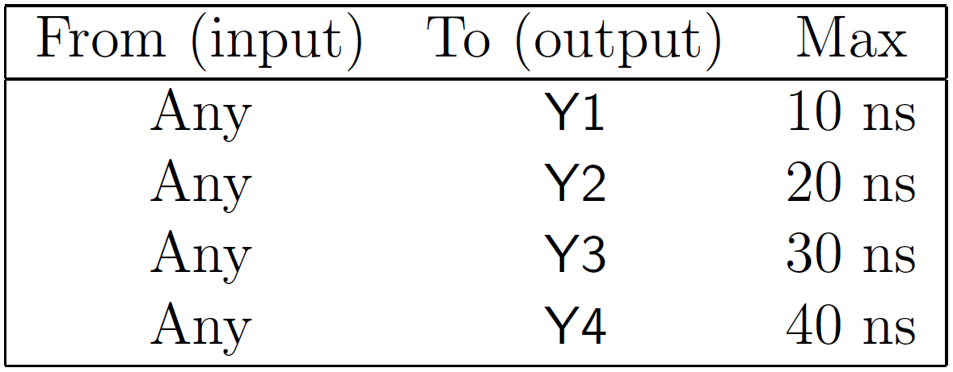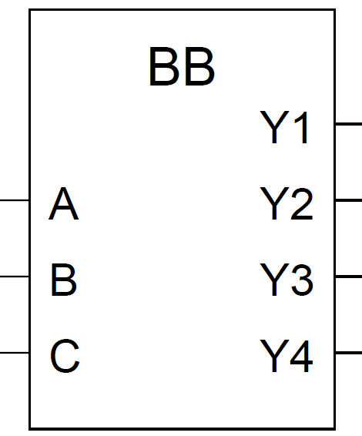  Suppose that the propagation delay of an XOR gate is 10 ns. By usign 2-input XOR gates only, design a circuit to compute Q =Y1 ⊕ Y2 ⊕ Y3 ⊕ Y4 so that the propagation delay from inputs A, B, C to output Q is minimized. What is this minimum propagation delay? |  |  |  |  |  |  |  |  |  |  |  |  |  | (10)
4 | - If an integer X is represented as 11101100 using signed magnitude representation, then the 8-bit 2's complement representation of X is : …………………  - If we add 11100100 (interpreted as 8-bit 2's complement) and X (also represented in 2's complement) using the 8 bits adder circuit, what are the values of carry (C), overflow (V) and sum (S):  C :………………………..  V : ………………………..  S : ……………………….. |  |  |  |  |  |  |  |  |  |  |  |  |  | (10)
5 | 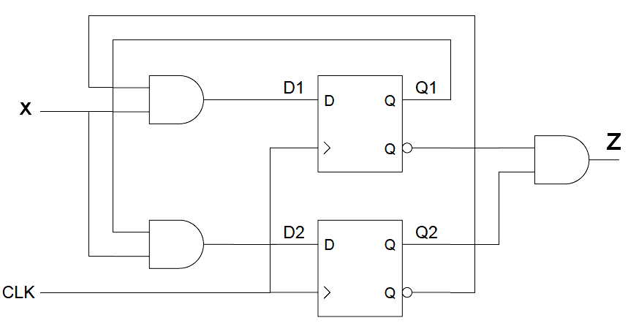  - Analyze the clocked synchronous state machine below and then draw a state diagram for this state machine (x: input, z:output).  - Is this machine a Mealy machine or a Moore machine? Explain?  - Fill in the transition/output table for the above state machine.  - Draw the Flow Chart for this ASM. |  |  |  |  |  |  |  |  |  |  |  |  |  | (20)
  Present | Next States |  | Output
  States | X = 0 | X = 1 | X = 0 | X = 1
  Q₁ Q₂ | Q₁⁺ Q₂⁺ | Q₁⁺ Q₂⁺ | Z | Z
  0 0
  0 1
  1 0
  1 1
6 | Find the decimal value for the following single precision floating point number: |  |  |  |  |  |  |  |  |  |  |  |  |  | (10)
  1 | 1 0 0 1 0 1 1 0 | 1 0 0 1 0 0 0 0 0 0 0 0 0 0 0 0 0 0 0 0 0 0 0
7 | There is an analog signal changing between 0 and 12 volt. Design a circuit to show the value of the signal on a 7 segments display. Displayed numbers is changed according to the value of the input signal : |  |  |  |  |  |  |  |  |  |  |  |  |  | (15)
 | Analog Signal (volt) |  |  | 0-2 |  | 2-4 | 5-6 | 6-7 | 7-8 | 8-9 | 9-10 | 10-12
 | Display Value |  |  | 0 |  | 1 | 2 | 3 | 4 | 5 | 6 | 7
 | Transition Table for JK Flip Flop
 | OUTPUT TRANSITION |  | FLIP-FLOP INPUTS
 | Q_{n} | Q_{n+1} | J |  | K
 | 0 | 0 | 0 |  | X
 | 0 | 1 | 1 |  | X
 | 1 | 0 | X |  | 1
 | 1 | 1 | X |  | 0

